
Sri Lanka Institute of Information Technology

Lab Submission
<Lab sheet No 7>

<IT24101931>
<Hettiarchchige G.D.P>

Probability and Statistics - IT2120
B.Sc. (Hons) in Information Technology

1.
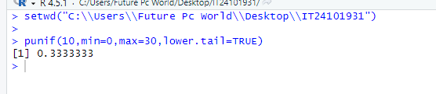

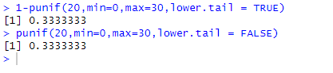

2.
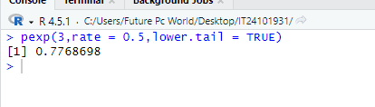

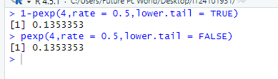

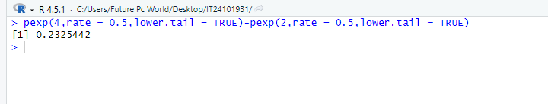

3.
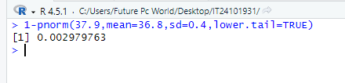

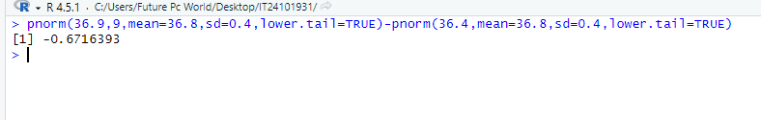

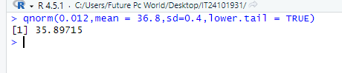

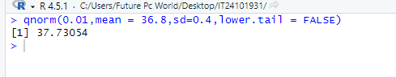

Exercise
1.
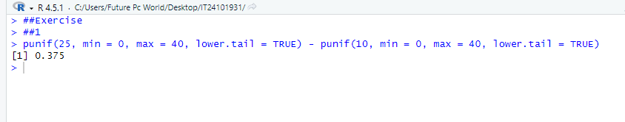
2.
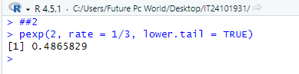
3.
